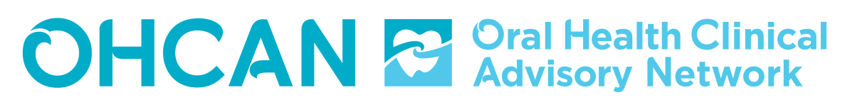
UPDATE NOVEMBER 2019

Public sector oral health service provision for high needs and vulnerable New Zealanders
The 2019 High Needs and Vulnerable report was released in September.
OHCAN are convening a working group consisting of clinicians, DHB personnel and consumer representatives to develop an implementation plan, with a set of feasible and acceptable strategies to operationalise the recommendations made in the report.
A key objective is equitable access to, and provision of, hospital-level dental care, i.e. secondary and tertiary services, for high needs and vulnerable New Zealanders.
The first of two meetings is on 11 November, with a follow-up meeting in December.
The final report is available (as is the previous report) on the OHCAN website: www.nzohcan.org.nz
Contact details
If you have any questions or feedback about any of our work please contact:
Moira Smith – Exec Chairperson moira.smith@otago.ac.nz
Jane Dunbier – Administrator jane@edresources.co.nz
Our work streams
High Needs and Vulnerable populations
Thank you to everyone who attended the Napier workshop on 25 July. There were over 60 attendees from a broad range of groups and organisations. The key outcomes of the meeting were included in the final report. Actions are now being considered to progress the Report’s recommendations – see above.
Clinical guidelines
The Child and Adolescent Clinical Guidelines document was completed in August and can be downloaded from the OHCAN website [ www.nzohcan.org.nz ]. About 1500 hard high-quality printed copies of the guidelines have now been distributed to DHB oral health services and all dental practices with a DHB Combined Dental Agreement. We intend to review and update the guidelines in 4 years’ time (2023). Any feedback on the guidelines would be welcome.
Oral health of older people
Liz and Moira continue to work on the primary care project with a view to piloting a project in a PHO.
Other news
Community water fluoridation – please continue to speak with your local MP and find other opportunities bout community water fluoridation and the urgent need to pass the changes in the Health (Fluoridation of Drinking Water) Amendment Bill.
NEXT EXEC MEETING: Wednesday 2 January 2020

